**Cryptology Assignment 5**

**Sanjith R**

**(241059044)**

**CYS, MAHE**

**1.Write a Python Program to perform brute force attack on the cipher text “dvvkzecfssprkkve"**

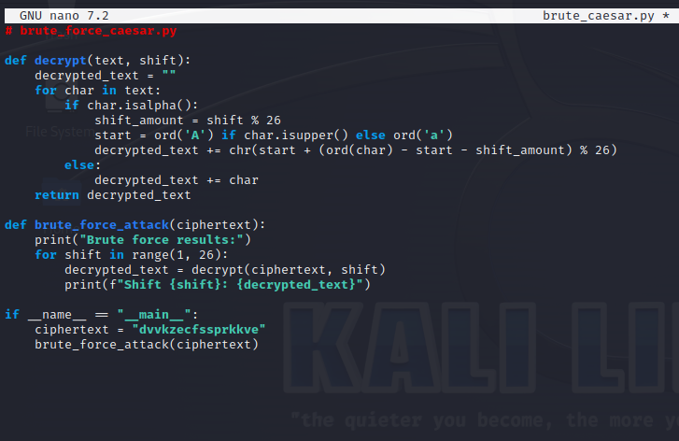

**Output**

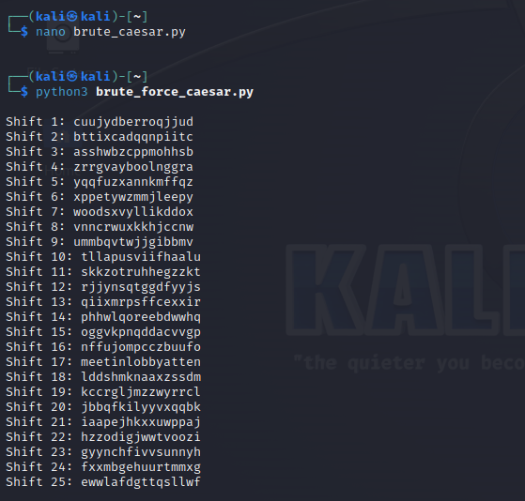

**2.Write a Python program to use brute force attack to decipher the message. Assume Affine cipher was used and "ab" is encrypted as "GL". Find the value of keys.**

XPALASXYFGFUKPXUSOGEUTKCDGFXANMGNVS

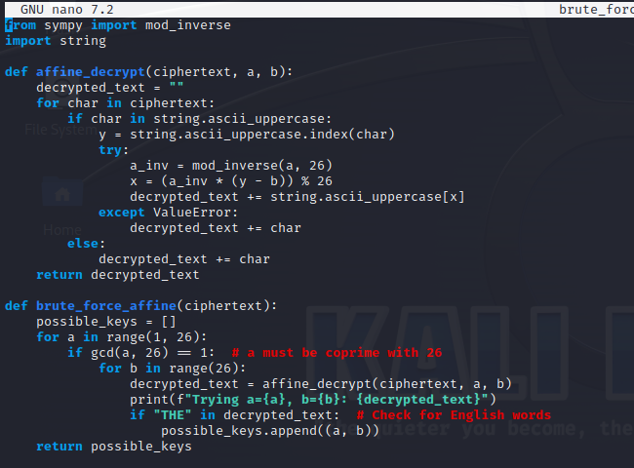

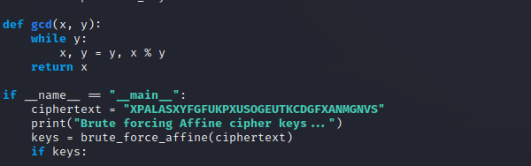

**Output**

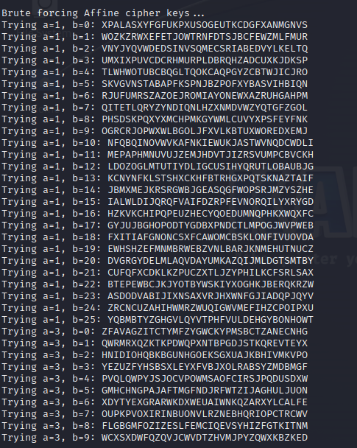

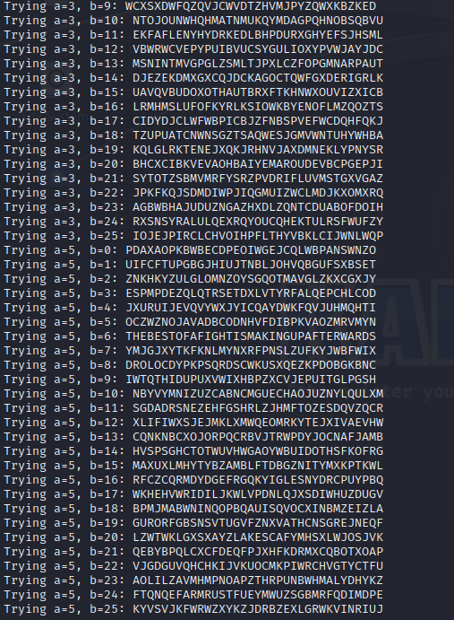

**3. Encrypt the plain text using Rail Fence cipher**

Taking **Hello World** as the example to this cypher.

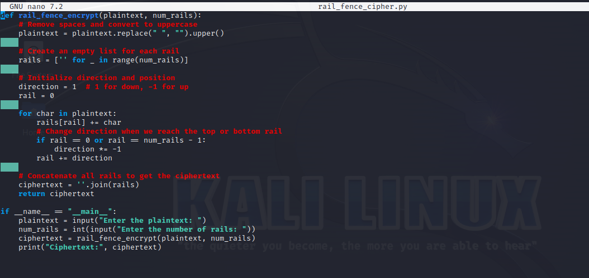

**Output**

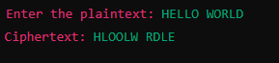

**4.**  **Decrypt the cipher using Rail Fence**

**AAIUJ SIHBE KTEAO TEADE SNUTF EAEMR TAHSA**

**RHROA YHNFO AITTE EHCBO FVCAT RNMNS NUTFE**

**RASHL WFHLN HIUJS IHTKS OEHNI FISAE FNTIG**

**RMRSO LSTIS OKIEH PEOE**

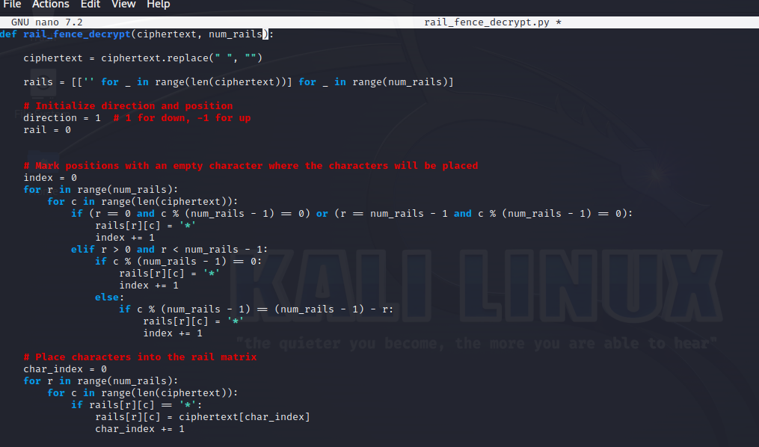

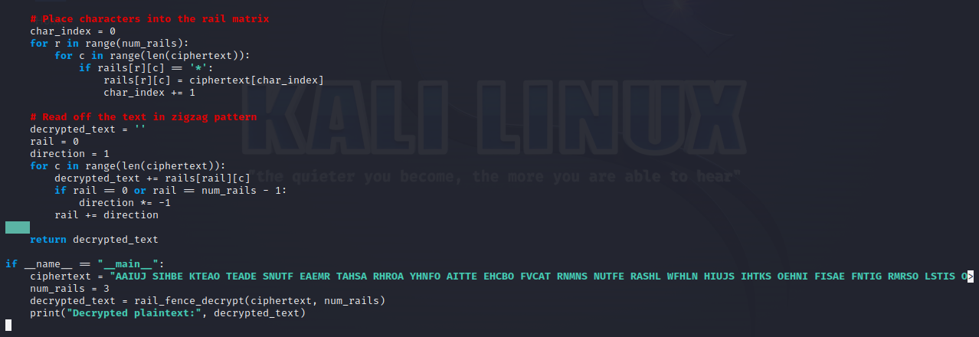

**Output**

